Fragkeys manual

Note: LED

The LEDs are mainly for use with transparent keycaps. All Cherry switches have place for LEDs.
The cathode is to the left (short leg)
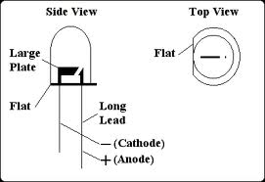
A LED should have 4-20mA of current. This is limited by resistor R7.
The included R7 is 22 Ohm and dimensioned for 20 LEDs (not blue or white).

5V – Vdiode = Vresistor
Vresistor/R = Idiodes (all diodes)
Idiodes/number of LEDs =5-20 (why not 10mA :))
Vdiode about 2V for red, green and about 3V for blue and white.

4 LEDs => R7 = 75 Ohm

Note: Soldering

I recommend having both leadfree solder and leadbased. The pins connected to ground can be hard to solder for inexperienced. And the mini USB connector as well.

Note: WASD or Arrow key config
It is possible to configure fragkeys mid keys as WASD or Arrows.
If you want WASD short jumpers. JP1-JP4 Pin 1-2, JP5 Pin 1-2 and 3-4
For arrow keys. JP1-4 Pin 2-3 JP5 Pin 2 to JP1 Pin3, JP5 Pin 4 to JP1 pin1

Building fragkeys:

- Start by putting all Resistors in their designated holes. R1-R3 are a little to big so they dont go all the way down. Bend the legs on the backside. Save the cutted legs from R4-R6 for use in step
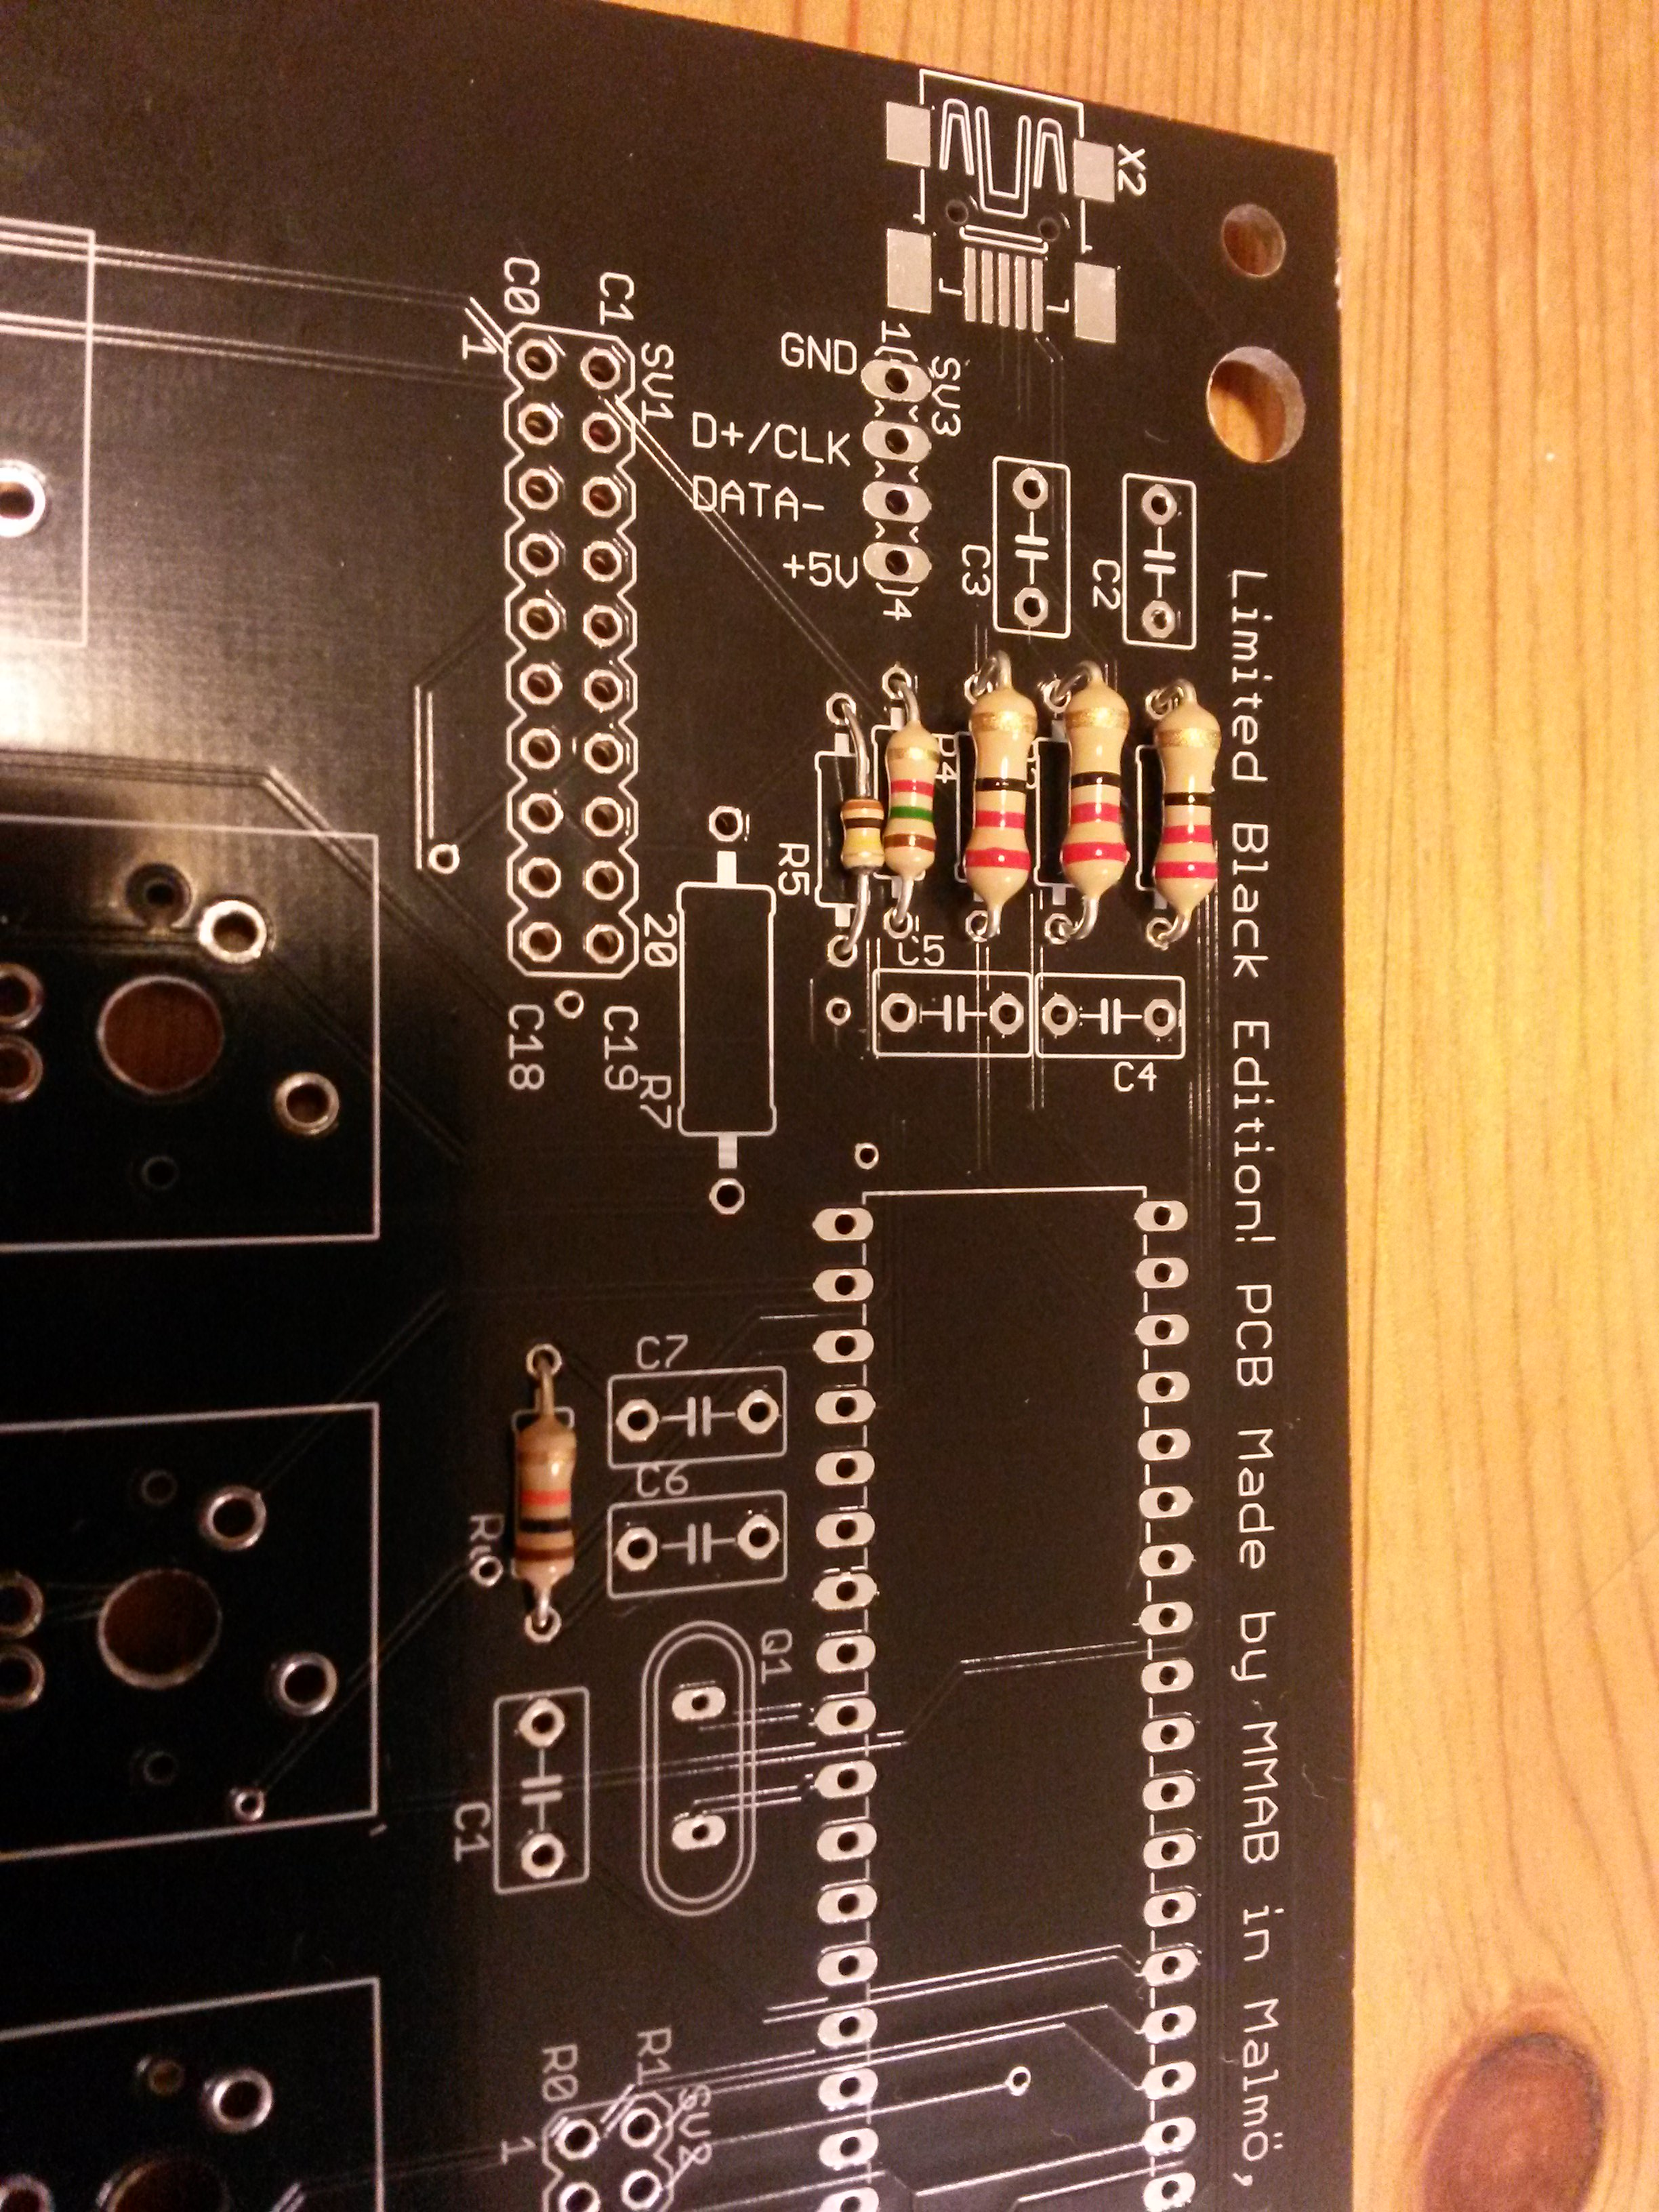
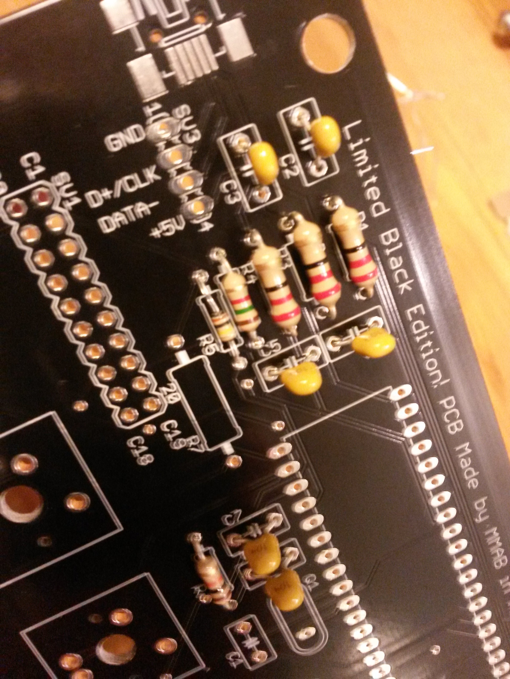
  - Then mount all the capacitors EXCEPT C1

3. Then mount the Holtec controller. Note the direction! Insert one side of the pins halfway. By holding the chip, press them inwards so they bend and the pins otherside can go into the holes.
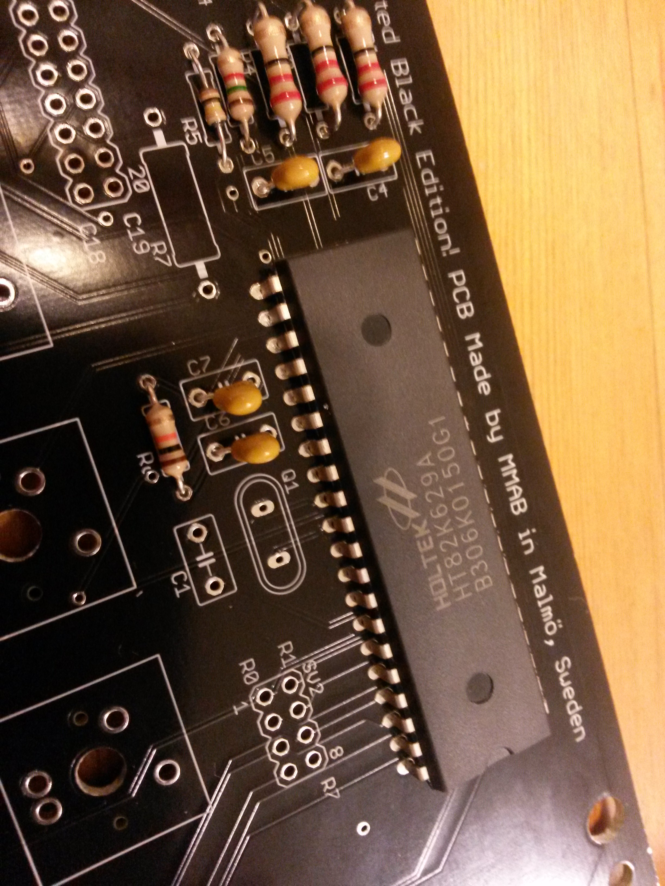
4. Then mount the crystal.
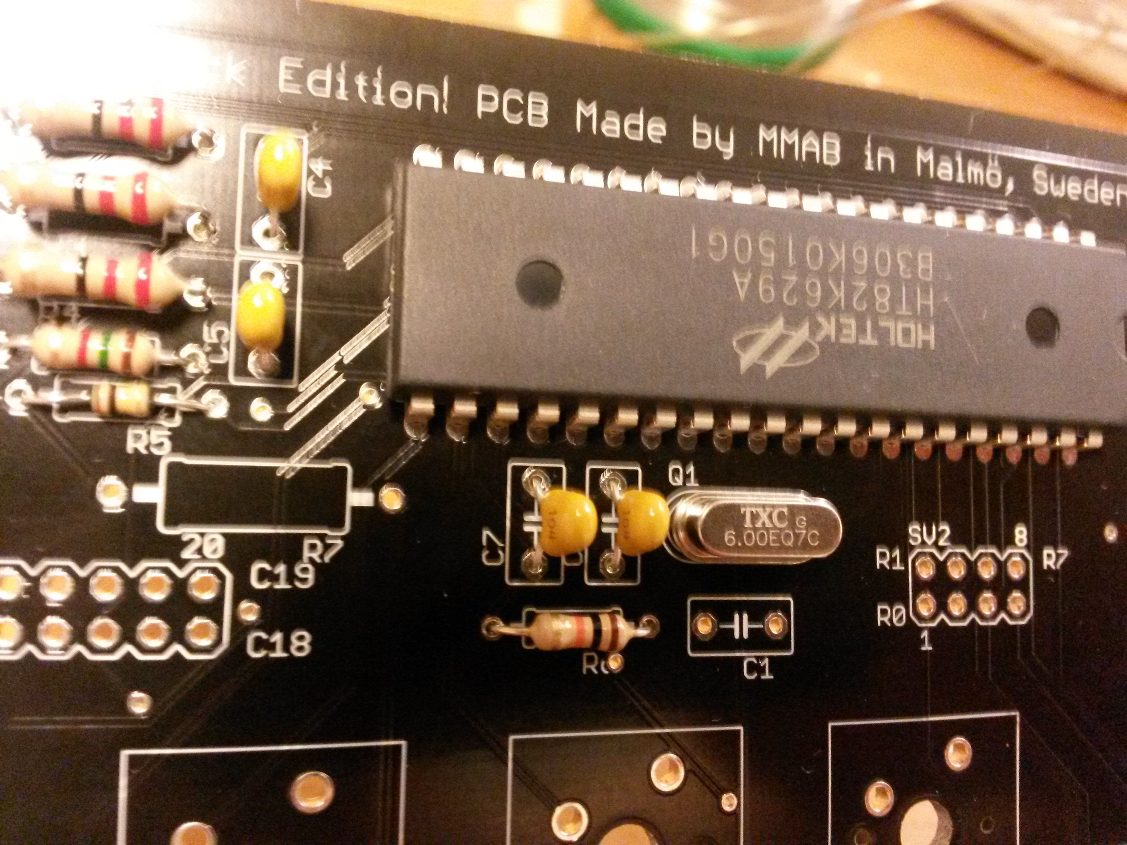
- Then mount C1. The minus side should be to the left. It is possible to bend C1 laying down. Which is recommended if you want to put a cover over the electronics.
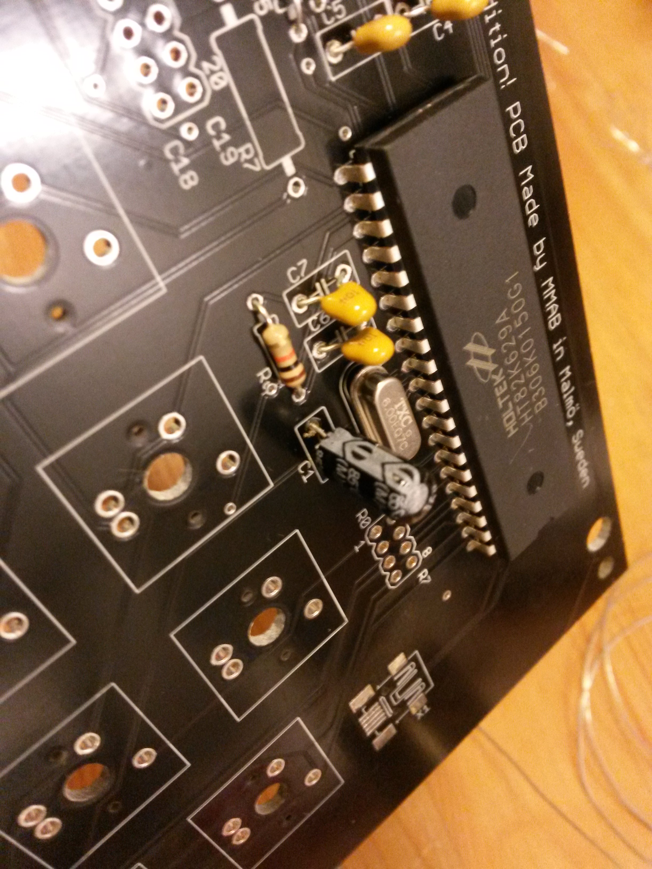

- Configuring WASD or Arrows. Picture is for WASD. Use the cutted resistor legs to patch the jumpers.
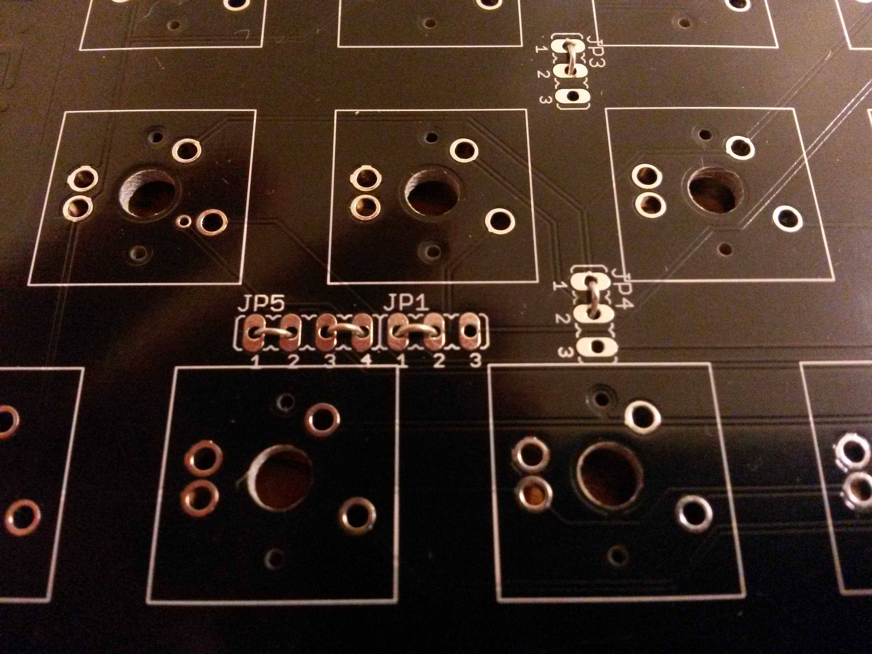

- Then solder the mini USB- connector or cut a cable and solder it to SV3 directly. This is probably the trickiest part (to solder the USB-connector)
a) If you have soldering paste, put a thin layer on the pins. Then align the connector. And if you like you can solder one the lugs on the side first.
b) Put a very little amount of solder on each pad. Align the connector and heat the pins all at once if possible.

If you are soldering the USB or PS2 cable directly this is the pin-out.
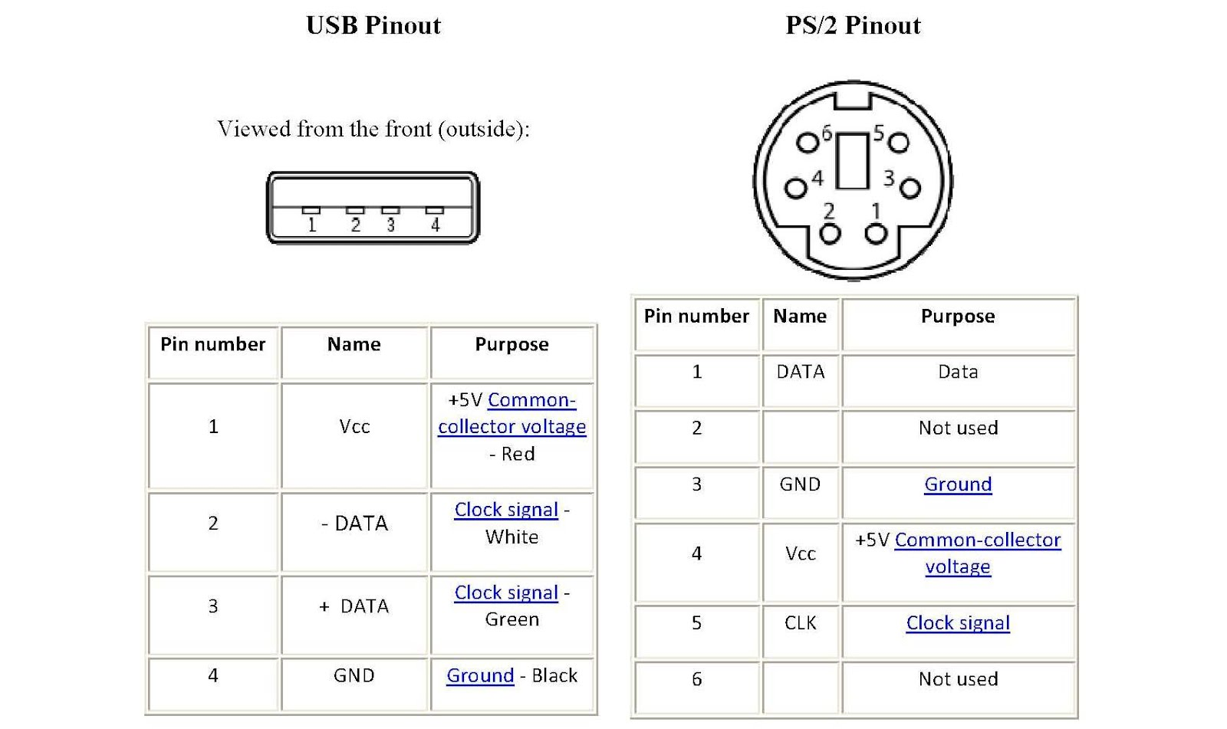
Check with a multimeter how the wires are connected to the USB/PS2 connector.
SV3 is inverted compared to the USB list above. = Pin1 Red go to SV3 Pin4 etc.

